2013-2016 Technology Plan

Delran Township Public Schools

Spring 2013

52 Hartford Road
Delran, NJ 08075
http://www.delranschools.org

Table of Contents

I. Stakeholders ……… 2

II. Technology Inventory 3-6

III. Needs Assessment 7-8

IV. Three-Year Goals 9

V. Three-Year Implementation and Strategies Table 10

VI. Professional Development Strategies 11

VII. Evaluation Plan 12-13

VIII. Funding Plan 14-16

IX. Board Resolution 17

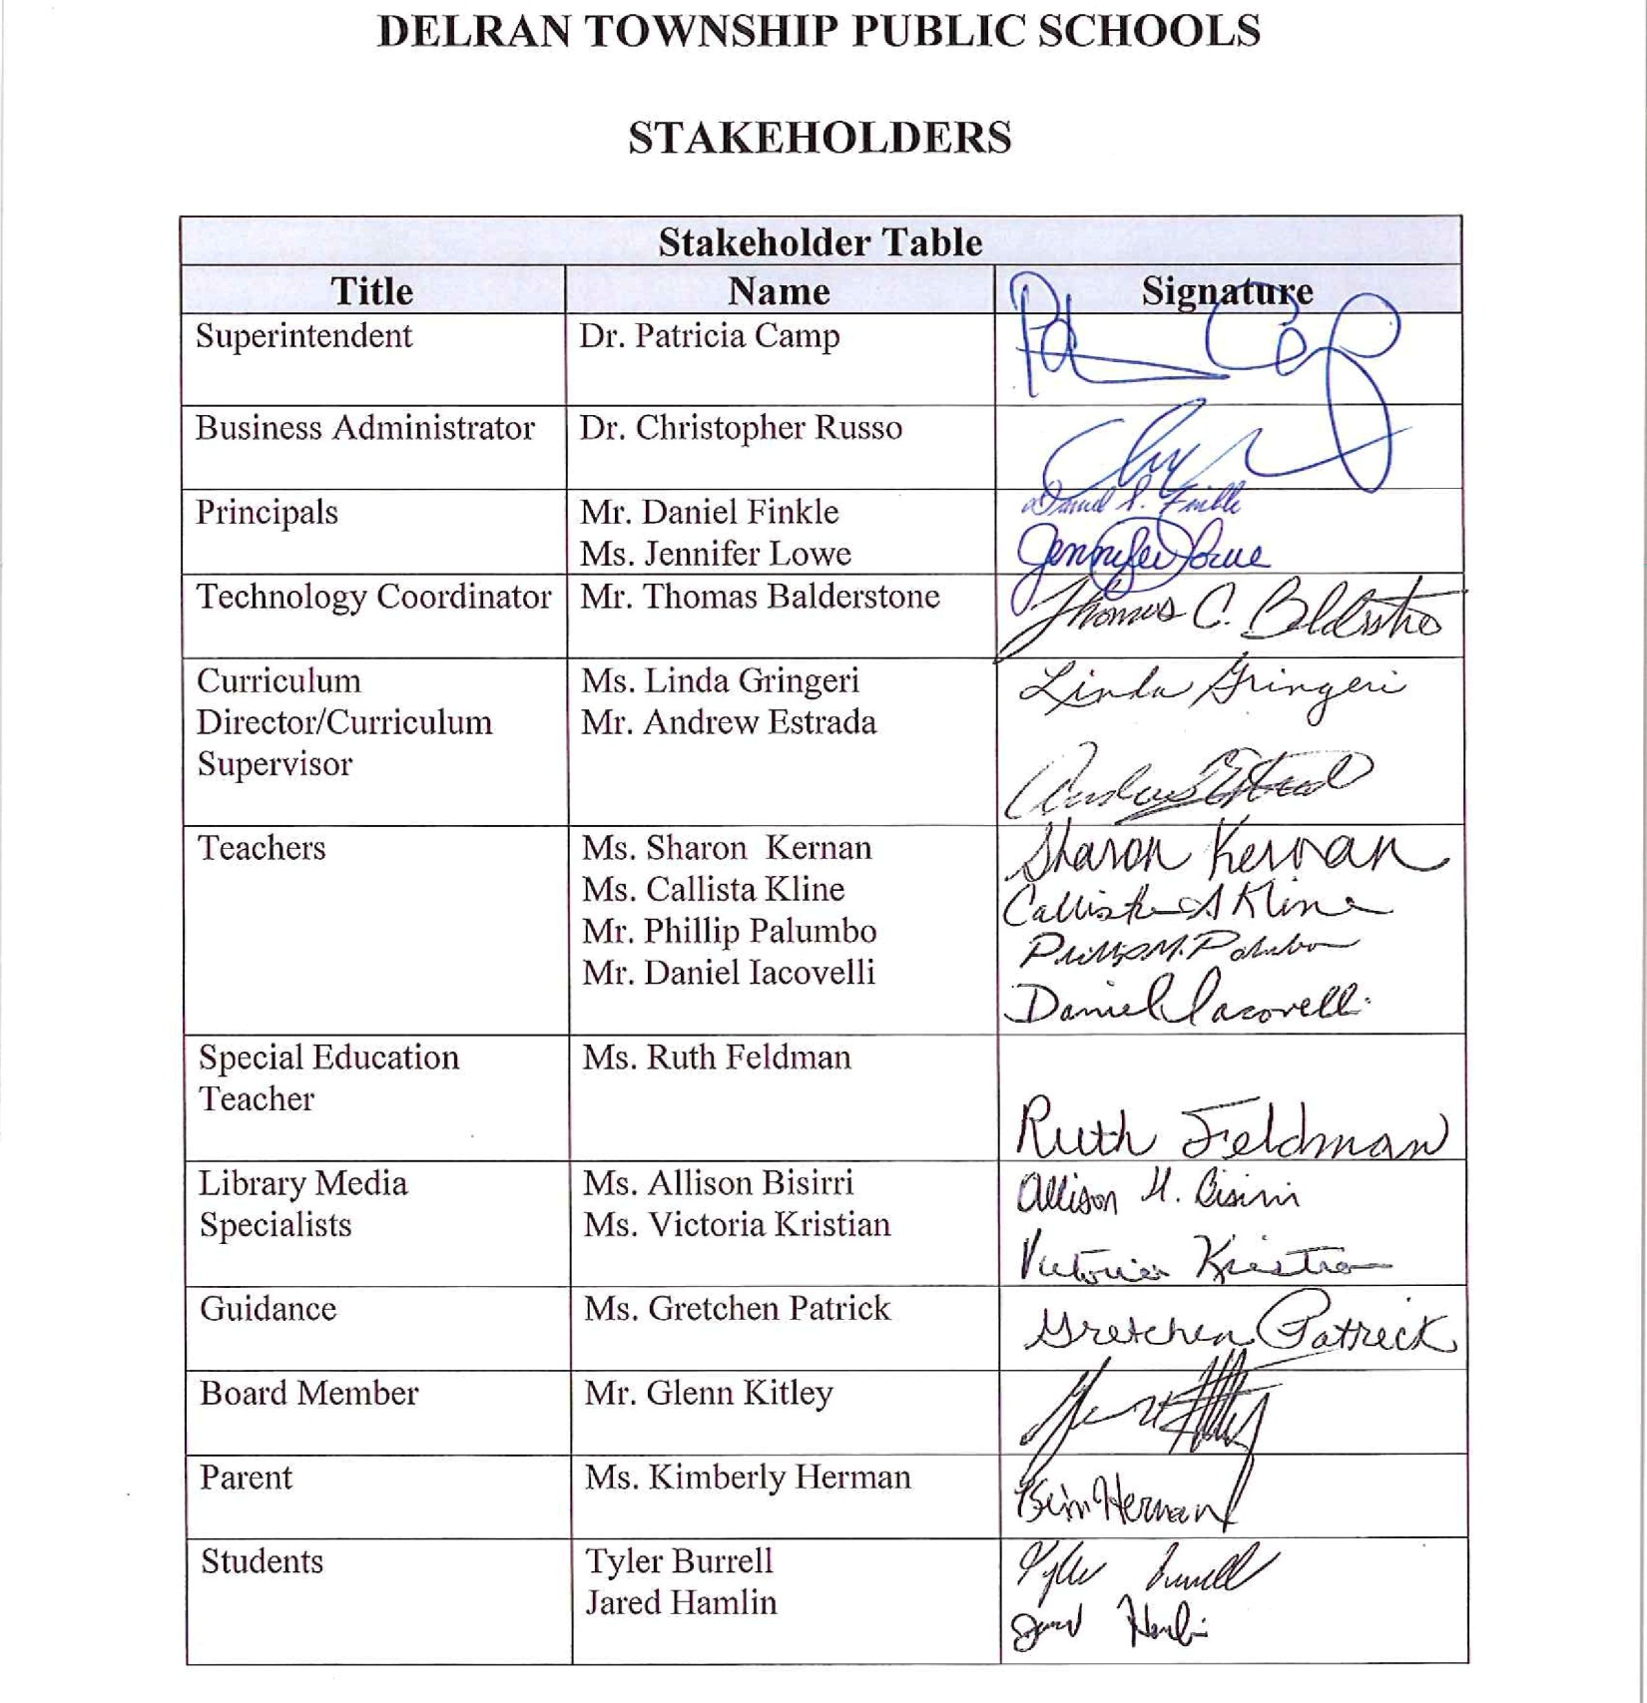
DELRAN TOWNSHIP PUBLIC SCHOOLS
Creating a Digital Learning Environment to transcend our students with the opportunity to educate, innovate, assess and recalibrate

Three-Year Educational Technology Plan Inventory Table

Area of Need | Describe for erate funded year 1  2013-2014 | Describe for erate funded year 2  2014-2015 | Describe for erate funded year 3  2015-2016
Technology Equipment including assistive technologies | Purge devices over 4 years old.  Replace 25% of total devices.  Explore, pilot and deploy new devices procurement based on curriculum objectives.  Replace staff laptops at DIS.  Design the 21st century special needs classroom with assistive technology.  Refresh and increase servers and capacity based on need and demand. | Purge devices over 4 years old.  Replace 25% of total devices.  Explore, pilot and deploy new devices procurement based on curriculum objectives.  Replace staff laptops at MB.  Implement the 21st century special needs classroom with assistive technology (K-5).  Refresh and increase servers and capacity based on need and demand. | Purge devices over 4 years old.  Replace 25% of total devices.  Explore, pilot and deploy new devices procurement based on curriculum objectives.  Implement the 21st century special needs classroom with assistive technology (6-12).  Refresh and increase servers and capacity based on need and demand.
Networking Capacity | Upgrade the Edge switches to at least 1Gbps to increase throughput.  Develop a switch deployment schedule and modify as need and demand increases  Evaluate and strengthen wireless connectivity to meet anticipated needs. | Upgrade the core switches to at least 10 Gbps to increase throughput.  Modify switch deployment schedule to accommodate need and demand.  Evaluate and strengthen wireless connectivity to meet anticipated needs. | Upgrade interschool core switches to at least 10 Gbps to connectivity.  Modify switch deployment schedule to accommodate need and demand.  Evaluate and strengthen wireless connectivity to meet anticipated needs.
Filtering Method | Remain in accordance with the FCC, District Policy & CIPA Guidelines.  Evaluate web content effectiveness and strengthen to meet district needs. | Remain in accordance with the FCC, District Policy & CIPA Guidelines.  Evaluate web content effectiveness and strengthen to meet district needs. | Remain in accordance with the FCC, District Policy & CIPA Guidelines.  Evaluate web content effectiveness and strengthen to meet district needs.
Software used for curricular support and filtering | Research, pilot and implement an Access On Demand interface for all devices (grades  3-5 & special needs).  Implement Free Cloud offering of Office 365 which would have the potential to provide the following:  Collaborative Learning network including One Note.  Online Meeting vehicle for offsite learning.  Student email & Cloud drive.  Maintain checkpoint web content filtering and security. | Implement an Access On Demand interface for all devices (grades 6-8 & special needs).  Upgrade server operating systems to 2013 offerings.  Integrate the Delran Academics Cloud with Office 365 Solution to maximize licensing dollars. | Implement an Access On Demand interface for all devices (grades  9-12 & special needs).  Upgrade email server to 2013 offerings.  Migrate all email to Office 365 Cloud -based free offering to secure 24-7 email availability.
Technical Support and maintenance | Technology Staff will be trained on existing and incoming services and devices.  Institute a District Technology Coach position pending funding.  Provide professional development for our Media Specialists to create a significant impact on technology use in everyday lessons.  Engage a network engineering firm to evaluate our network and make recommendations.  Outsource critical areas of expertise necessary for efficient district operation. | Technology Staff will be trained on existing and incoming services and devices.  Maintain a District Technology Coach position pending funding.  Develop a co-teaching model with our Media Specialists to create a significant impact on technology use in everyday lessons.  Engage a network engineering firm to evaluate our network and make recommendations.  Outsource critical areas of expertise necessary for efficient district operation. | Technology Staff will be trained on existing and incoming services and devices.  Maintain a District Technology Coach position pending funding.  Engage a co-teaching model with our Media Specialists to create a significant impact on technology use in everyday lessons.  Engage a network engineering firm to evaluate our network and make recommendations  Outsource expertise critical areas of expertise critical to districts operation.
Telecommunications equipment and services | Evaluate telephone system replacement needs.  Negotiate for best pricing and services for current Internet transport and bandwidth needs. | Evaluate telephone system replacement needs.  Negotiate for best pricing and services for current Internet transport and bandwidth needs.  Increase Bandwidth to 100 mbps for every 1000 students to comply with PARCC Assessment. | Evaluate telephone system replacement needs.  Negotiate for best pricing and services for current Internet transport and bandwidth needs.
Other Services: | Provide for electrical transformers and resources to accommodate the digital learning centers for assessments.  Evaluate cabling needs and covert to fiber when there is need and demand. | Buy modular furniture to create convertible classrooms for dual purpose as a classroom or a wired digital assessment center.  Evaluate cabling needs and covert to fiber when there is need and demand. | Evaluate cabling needs and covert to fiber when there is need and demand.

TECHNOLOGY INVENTORY – NARRATIVE

New devices including assistive technologies will be purchased to address the needs of our student population, including our special education population, to better prepare for online digital assessments (i.e., PARCC) and to create an educational, impactful digital learning community. Switches and other networking hardware will be increased to manage the curricular demands for the administration, faculty and student use throughout the day.

Checkpoint web content filtering currently protects the entire Delran Township Public Schools community. Our district is continuing to evaluate our filtering method to monitor safe, online learning resources.

Software and hardware initiatives will be targeted to maximize the curricular impact for every student. Educational offerings provided by Microsoft and other vendors will be piloted and evaluated for in class use. Microsoft’s Office 365 free educational solutions include: Collaborative Network Learning including One Note, an online meeting vehicle for offsite learning, student email, and student cloud storage solutions. Access on Demand is also being recommended for all of the district devices to better leverage student owned devices, dissemination of curricular content, and extending the learning day past school business hours to improve student performance and access to online learning.

The saturation of technology in today’s society and the curricular focus to ensure that no student is left behind, bridging deficiencies with technology is a viable tool to support student success. Developing digital learning communities will encourage and aid online assessments which will provide every teacher with immediate assessment results and enhance the process for differentiated instruction. The PARCC assessment will be only one tool in our arsenal of technology and assessments to provide for rigor and relevance in every student’s educational experience.

Finally, there is a quintessential need for a district technology coach to assist our teaching staff, to even the technology playing field in the upcoming years. All these recommendations are subject to curricular need, board approval and budgetary allocations.

NEEDS ASSESSMENT

Describe the needs assessment process that was used to identify the necessary telecommunication services, hardware, software, and other services to improve education.

Telecommunications Service

On an annual basis, surveys are disseminated to key personnel in the district to identify the current quality of service with our telephone system and internet service. It is imperative to solicit recommendations to improve or add to our existing phone and internet plans. Specifically, the district requests recommendations for instructional needs to determine bandwidth, internet speed and internet utilization. Curricular initiatives involving online assessments require internet minimum speeds. The technology staff creates a plan for increasing services at least annually but also in response to monitoring reports and trends.

These services would include Telephone Services, Internet Transport and Internet Bandwidth.
The needs assessment would take one, some or all, but not limited to the following forms:

Telephone Service:
- Evaluate the service logs for telephone services, its downtime and root cause.
- Research the benefits of the most recent telephone technology and the value of the improved technology.
- Determine the end of life timeline for telephone technology and a realistic continued support window.
- Survey the end user for the general quality of service and determining satisfaction with the current technology.

Internet Bandwidth and Internet Transport:
- Evaluate the IT requests for the Internet services, its downtime and root cause.
- Research the benefits of the most recent transport services and the value of the improved technology.
- Determine the end of life for the Internet transport and a realistic continued support window. is satisfactory
- Gauge the number of end users to anticipate the services including future personal devices.
- Anticipate classroom management shifts to utilize these services daily including the number of devices.
- Determine curricular shifts to wireless and mobile devices including electronic media.
- Establish quarterly focus group meetings to target immediate problems and future needs.
- Perform periodic classroom observations to evaluate everyday use and needs.
- Schedule joint grade level meetings (K-5) and academic department/building meetings (6-12) to explore new demands in the classroom.

Hardware

The process we use to determine instructional needs is multi-faceted. The curriculum determines what classroom equipment is necessary. Once communicated to the technology staff, they will make recommendations for replacement of servers, firewalls, routers, switches, operating systems, and deployment schedules.

Hardware includes: End devices, network switches, controllers, access points, network servers, storage space, firewalls, and network security, UPS battery backups, emergency generators, backup and disaster recovery systems, security Cameras, servers, and recording systems.

The needs assessment would take one, some, or all, but not limited to the following forms:
- Evaluate the IT requests, network engineering service, maintenance logs for hardware, the duration of the downtime, and the root cause.
- Research the benefits of the most recent hardware and the value of the improved technology.
- Determine the end of life for the hardware and create a realistic support window.
- Survey the end user for the general quality of service and whether the current technology is satisfactory.
- Gauge the number of end users anticipated to utilize the hardware and the services they provide including future personal devices and increasing populations.
- Anticipate classroom management shifts to utilize hardware and the service they provide daily including the number of devices and the population of users.
- Determine curricular shifts to new hardware, wireless connectivity and mobile devices, including what types of electronic media will be incorporated and the security expected to be contained.
- Establish quarterly focus group meetings to target immediate problems and future needs.
- Perform periodic classroom observations to evaluate everyday use and needs.
- Schedule joint grade level meetings (K-5) and academic department/building meetings (6-12) to explore new demands in the classroom.

Software

As with the process stated above for hardware, the curriculum drives software purchases. The district thoroughly evaluates the needs of the students and teachers by district-created surveys for parents, students and staff. Additionally, the District Technology Committee meets regularly to discuss district and building needs. Furthermore, administration and staff conduct research of software programs and pilot the programs which assist in the delivery of instruction.
Included would be instructional software, subscriptions and assessment programs, server operating systems, services software including food services, business/human resources, payroll, recruitment and transportation, student information systems, firewall software and operating systems, wireless controller, software and operating systems, network switching software, monitoring and operating systems, HVAC software, interfaces and operating systems, security camera software monitoring and operating systems.

The needs assessment would take one, some or all, but not limited to the following forms:
- Evaluate the IT requests, network engineering service, maintenance logs for the software, the duration of the downtime, and the root cause.
- Research the benefits of the most recent software and the value of the improved technology.
- Determine the end of life for the software and a realistic support window.
- Survey the end user for the general quality of service and whether the current technology is satisfactory.
- Gauge the number of end users anticipated to utilize the software and the services they provide, including the number of personal devices and increasing populations.
- Anticipate classroom management shifts to utilize software and the service they provide daily and on how many devices for what population of users
- Determine curricular shifts to new software, wireless connectivity and mobile devices including the types of electronic media to be incorporated and the security expected to be contained.
- Establish quarterly focus group meetings to target immediate problems and future needs.
- Perform periodic classroom observations to evaluate everyday use and needs.
- Schedule joint grade level meetings (K-5) and academic department/building meetings (6-12) to explore new demands in the classroom.

Other Services

Some of the other services necessary to increase our technological capacity involve our Building and Grounds department. Electrical supply for technology equipment and classroom devices are areas of need for some instructional spaces. A review of classroom design is necessary for our rooms to be easily converted into digital assessments. Furniture purchases may also be needed to create the type of environment for these assessments.

- Evaluate the service logs for the electrical and cabling services, its downtime and root cause.
- Research the benefits of the most recent electrical and cabling systems and the value of the improved technology.
- Determine the end of life for the electrical and cabling systems and a realistic continued support window.
- Survey the end user for the general quality of service and whether the current technology is satisfactory.

THREE –YEAR GOALS FOR 2013-16

GOAL 1: To continue to educate staff and students to compete in our technological world.

Objective 1A: Provide computer instruction at the K-2 level.
Objective 1B: Establish an online tutorial program for teachers and media specialists in addition to the current District Continuing Education Courses (DCEC).

GOAL 2: Provide 21st century technologically ready classrooms for all buildings.

Objective 2A: Purchase and install additional Promethean Boards and accessories and update current Boards where necessary.
Objective 2B: Replace/update computers, telecommunications devices, computer labs and other instructional spaces to better prepare for digital assessments.
Objective 2C: Purchase assistive technology equipment where needed.

GOAL 3: Provide ample support and resources to promote technological integration and educational excellence throughout every curriculum, classroom, and within every student.

Objective 3A: Update the K-8 technology curriculum to reflect the ever-changing needs of our 21st century learners.
Objective 3B: Arrange office hours for technical assistance for teachers with current technical support staff.
Objective 3C: Hire an additional technology support specialist to better provide for the technological needs at the K-5 level.

DELRAN TOWNSHIP PUBLIC SCHOOLS
Three-Year Implementation Activity Table

Strategies and activities that relate to the district, nonpublic or charter school’s goals and objectives may be completed on the sample implementation table. If the goals and objectives were numbered in the THREE-YEAR GOALS section of this checklist, use corresponding numbers in the table below. The use of this table is optional and is provided as a convenience.

Three-Year Technology Implementation Activity Table
District Goal and Objective | Strategy/Activity | Timeline | Person Responsible | Documentation
Goal 1-Obj A | Provide computer instruction at the K-2 level. | 2013-14 and ongoing | Principal/  Teacher | Course Schedule/Lesson Plans
Goal 1-Obj B | Establish an online tutorial program for teachers and media specialists in addition to the current District Continuing Education Courses (DCEC). | 2013-14 and ongoing | Director of Curriculum/  Staff and Teachers | Courses on District Website
Goal 2-Obj A | Purchase and install additional Promethean Boards and update current Boards where necessary. | 2013-14 | Technology Coordinator/  Business Admin. | Approved District Budget
Goal 2-Obj B | Replace/update computers, telecommunications devices, computer labs and other instructional spaces to better prepare for upcoming digital assessments. | 2013-15 | Technology Coordinator/  Business Admin. | Approved District Budget
Goal 2-Obj C | Purchase assistive technology equipment where needed. | 2013-15 | Director of Student Services | Approved District Budget
Goal 3-Obj A | Update the K-8 technology curriculum to reflect the ever-changing needs of our 21st century learners. | 2013-14 | Director of Curriculum, Supervisors, Staff | Approved K-8 Curriculum
Goal 3-Obj B | Arrange office hours for technical assistance for teachers with current technical support staff. | 2013-14 | Technology  Coordinator | Office Hours Schedule
Goal 3-Obj C | Hire an additional technology support specialist to better provide for the technological needs at the K-5 level. | 2014-15 | Supt./Bus.  Admin. | Approved District Budget
DELRAN TOWNSHIP PUBLIC SCHOOLS
Professional Development Table

Professional development detail is needed for the first school year of the educational technology plan.
The use of this table is optional and is provided as a convenience.

Educators’ Proficiency/ Identified Need | Ongoing, sustained, high-quality professional development planned | Support
Ensure new staff are prepared technologically for use of classroom equipment including the Promethean Board. | Training made available to teachers by in-house trainers/online tutorials. | District Continuing Education Courses (DCEC) will be provided after school as well as opportunities during in-service days, PCPEP days (curriculum planning days), new staff orientation days, and online tutorials.
Training on MAC/PCs, Promethean Board, iPads and other devices for current staff. | Training provided by in-house trainers/online tutorials and out-of-district training. | DCEC, in-service days, PCPEP days, out-of-district workshops, YouTube videos, and other training modules (i.e., Atomic Learning).
Technology courses continued after school (DCEC) and online for staff. | Several courses and training opportunities will be provided for faculty/staff. | District faculty/staff will turnkey train during in-service days, PCPEP days and our DCEC program. Online tutorials will also be made available and determined by staff survey.
Instruction on use of Realtime (student data system) for new staff and for current staff as recommended in the Dist. Strategic Plan. | Online tutorials and other opportunities made available by in-house trainers for Parent Portal and other Realtime features. | District staff will provide training during the summer for new teachers, during the school year, and provide online tutorials where possible.

DELRAN TOWNSHIP PUBLIC SCHOOLS
Evaluation Plan Table
The evaluation narrative must include how telecommunications services, hardware, software and other services will improve education. Telecommunications services are leased, tariffed, contracted, or month-to-month services that are used to communicate information electronically between sites. The services MUST be provided by an eligible Telecommunications Service Provider. Examples of Telecommunications Services for E-Rate include T-1 lines, basic telephone service, and ISDN. Broadcast services (such as over-the-air radio and television) and cable TV are not considered Telecommunications Services.
The burden of proof for any federal inquiry lies with the district, and they should be able to support their process with methodology and documentation. The use of this table is optional and is provided as a convenience.

Educational Technology Plan Evaluation Narrative

Describe the process to regularly evaluate how...

- Telecommunication services, hardware, software and other services are improving education. | Our district has a five-year curricular review cycle which includes assessment, development, implementation, monitoring and evaluation which will continue during the period of 2013-16. The principals, supervisors and teachers work closely to identify resources including software and media to support and enhance learning and instruction. During this process, should revisions become necessary due to budgetary constraints and/or technological needs, the curriculum committee and/or the district Technology committee will convene. Telephone and internet services are evaluated on an annual basis with information provided to the technology staff.
- Effective integration of technology is enabling students to meet challenging state academic standards. | The Delran Township School District continues to place student achievement and mastery of the Common Core Standards as priorities. Goals and objectives established by building principals and supported by teachers and media specialists include but are not limited to increased student performance on the NJ ASK and HSPA assessments and preparation for the PARCC assessments. The District Technology Committee will meet regularly during the 2013-16 time period to monitor the progress in our district. Additionally, the administrative team will have the opportunity to address issues during administrative meetings and at other times during the year should goal revision become necessary.
c. The LEA is meeting the identified goals in the educational technology plan. | The district technology plan was created and reviewed by the District Technology Committee. Surveys were provided to staff, students and the community in 2013. The committee will meet over the next three years (2013-16) to review the established goals and timelines and adjust accordingly. Furthermore, the plan will be shared with the building principals to ensure the goals are communicated and workable.

Funding Plan

The majority of funding for the Technology Plan comes from the yearly operating
budget. Most of these funds are allocated in the Technology Department budget. At the same time, each school budget supports technology integration and training for staff.

The district has a separate line item in the budget to support, refresh and replace
existing technologies. Professional development is funded through the Office of Curriculum and Instruction and is the primary resource for technology-based training for the staff. The Director’s budget also supports technology-related curriculum development.

Maintenance contracts, training, parts, supplies, networking equipment, servers, Internet connectivity, software, on-line resources, and web resources, are all funded through the technology budget.

The primary source for hardware funding is the refresh and replacement line item in the
district budget. This yearly expenditure allows the district to plan a replacement cycle for obsolete hardware. Before any hardware is replaced, the effectiveness of the hardware is evaluated to determine if replacement of the hardware is warranted, or, if a different
configuration would be more appropriate.

Each year, the district expects to spend the following with annual increases due to the infrastructure requirements, increased licensing costs, student population, and curricular needs:

Ongoing Licensing & Subscriptions | $ 75,000.00
Technology Classroom Deployment | $ 125,000.00
Subcontracted Staff, Network Engineers and Services | $ 175,000.00
Infrastructure, Maintenance and Enhancement | $ 150,000.00
Technology Operating Budget | $ 25,000.00

The district receives funds from the E-Rate program and the NCLB Federal Consolidated Grant. These funds are used as supplemental support for the Technology Plan. As these monies are received, they are used to support emergency hardware replacement, professional development, curriculum development, and the acquisition of resources.

DELRAN TOWNSHIP PUBLIC SCHOOLS Technology Plan
Funding Plan

Three-Year Educational Technology Plan Anticipated Funding Table
(First Year)
ITEM | DESCRIPTION OF ITEM TO BE PURCHASED | FEDERAL  FUNDING | STATE  FUNDING | LOCAL FUNDING | MISC. (e.g.  Donations, Grants)
Technology Equipment |  |  |  | 100,000
Network |  |  |  | 70,000
Capacity |  |  |  | 50,000
Filtering |  |  |  | 20,000
Software |  |  |  | 75,000
Maintenance |  |  |  | 190,000
Upgrades |  |  |  | 30,000
Other services |  |  |  | 15,000

DELRAN TOWNSHIP PUBLIC SCHOOLS Technology Plan
Funding Plan Table
Three-Year Technology Plan Projected Funding Table (2014-2016)
ITEM | 2014 | 2015 | 2016 | % LOCAL FUNDING
Technology Equipment | 100,000 | 100,000 | 100,000 | 100
Network | 70,000 | 70,000 | 70,000 | 100
Capacity | 50,000 | 50,000 | 50,000 | 100
Filtering | 20,000 | 20,000 | 20,000 | 100
Software | 75,000 | 75,000 | 75,000 | 100
Maintenance | 190,000 | 190,000 | 190,000 | 100
Upgrades | 30,000 | 30,000 | 30,000 | 100
Other services | 15,000 | 15,000 | 15,000 | 100

BOARD RESOLUTION
